Rental

tntrg_03

2023-10-02

library(foreign)   
library(car)

## Loading required package: carData

library(lmtest)

## Loading required package: zoo

##   
## Attaching package: 'zoo'

## The following objects are masked from 'package:base':  
##   
## as.Date, as.Date.numeric

library(AER)

## Loading required package: sandwich

## Loading required package: survival

library(plm)  
library(stargazer)

##   
## Please cite as:

## Hlavac, Marek (2022). stargazer: Well-Formatted Regression and Summary Statistics Tables.

## R package version 5.2.3. https://CRAN.R-project.org/package=stargazer

library(readxl)  
library(gplots)

##   
## Attaching package: 'gplots'

## The following object is masked from 'package:stats':  
##   
## lowess

rental <- read.csv("E:/KTL/KTL_02/Chương 11/rental.csv")  
#rental  
#attach(rental)  
dim(rental)

## [1] 128 23

head(rental,3)

## city year pop enroll rent rnthsg tothsg avginc roll lpop lrent  
## 1 1 80 75211 15303 197 13475 26167 11537 9.635804 11.22805 5.283204  
## 2 1 90 77759 18017 342 15660 29467 19568 9.799071 11.26137 5.834811  
## 3 2 80 106743 22462 323 14580 37277 19841 10.019580 11.57818 5.777652  
## ltothsg lrnthsg lavginc clenroll clpop clrent cltothsg clrnthsg  
## 1 10.17225 9.508592 9.353314 . . . . .  
## 2 10.29103 9.658865 9.881651 -15293.2 0.0333166 0.5516071 0.1187716 0.1502733  
## 3 10.52613 9.587406 9.895506 . . . . .  
## clavginc pctstu cpctstu y90  
## 1 . 20.34676 . 0  
## 2 0.5283365 23.17031 2.823551 1  
## 3 . 21.04307 . 0

coplot(rent~avginc|city, type = "p", data=rental)

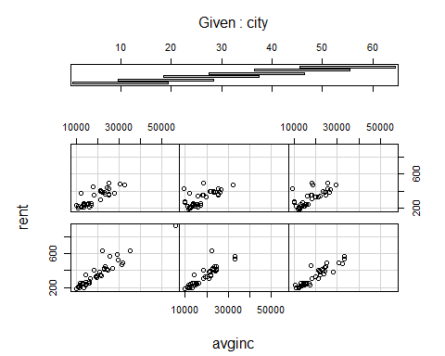

plotmeans(rent ~ city, main="Heterogeineityacross city", data= rental)#tính không nhất xuyên suốt

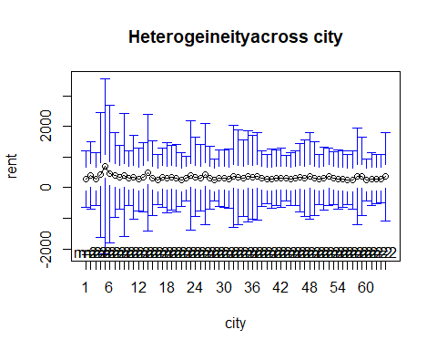

scatterplot(rent~city|year, boxplots=FALSE, smooth=TRUE, reg.line=FALSE, data=rental)

## Warning in plot.window(...): "reg.line" is not a graphical parameter

## Warning in plot.xy(xy, type, ...): "reg.line" is not a graphical parameter

## Warning in axis(side = side, at = at, labels = labels, ...): "reg.line" is not  
## a graphical parameter  
  
## Warning in axis(side = side, at = at, labels = labels, ...): "reg.line" is not  
## a graphical parameter

## Warning in box(...): "reg.line" is not a graphical parameter

## Warning in title(...): "reg.line" is not a graphical parameter

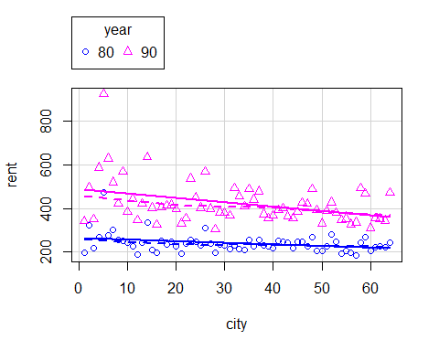

### Mô hình tác động không quan sát được là: log(rent)=bta0 +alpha*y90 + bta1*log(pop)+bta2*avginc+bta3*pctstu+a_i+u_i

print("Uoc luong mo hinh bang POLS")

## [1] "Uoc luong mo hinh bang POLS"

pols_rent=plm(lrent~y90+lpop+avginc+pctstu,data = rental,index = c("city","year"),model = "pooling")  
summary(pols_rent)

## Pooling Model  
##   
## Call:  
## plm(formula = lrent ~ y90 + lpop + avginc + pctstu, data = rental,   
## model = "pooling", index = c("city", "year"))  
##   
## Balanced Panel: n = 64, T = 2, N = 128  
##   
## Residuals:  
## Min. 1st Qu. Median 3rd Qu. Max.   
## -0.248639 -0.069106 -0.017808 0.039395 0.498452   
##   
## Coefficients:  
## Estimate Std. Error t-value Pr(>|t|)   
## (Intercept) 4.5555e+00 2.4339e-01 18.7172 < 2.2e-16 ***  
## y90 2.9358e-01 2.9201e-02 10.0539 < 2.2e-16 ***  
## lpop 3.6812e-02 2.0901e-02 1.7613 0.08067 .   
## avginc 2.6990e-05 2.1719e-06 12.4273 < 2.2e-16 ***  
## pctstu 4.5335e-03 9.3771e-04 4.8347 3.898e-06 ***  
## ---  
## Signif. codes: 0 '***' 0.001 '**' 0.01 '*' 0.05 '.' 0.1 ' ' 1  
##   
## Total Sum of Squares: 14.058  
## Residual Sum of Squares: 1.6787  
## R-Squared: 0.88059  
## Adj. R-Squared: 0.87671  
## F-statistic: 226.765 on 4 and 123 DF, p-value: < 2.22e-16

ols_rent=lm(lrent~y90+lpop+avginc+pctstu,data = rental)  
summary(ols_rent)

##   
## Call:  
## lm(formula = lrent ~ y90 + lpop + avginc + pctstu, data = rental)  
##   
## Residuals:  
## Min 1Q Median 3Q Max   
## -0.24864 -0.06911 -0.01781 0.03940 0.49845   
##   
## Coefficients:  
## Estimate Std. Error t value Pr(>|t|)   
## (Intercept) 4.556e+00 2.434e-01 18.717 < 2e-16 ***  
## y90 2.936e-01 2.920e-02 10.054 < 2e-16 ***  
## lpop 3.681e-02 2.090e-02 1.761 0.0807 .   
## avginc 2.699e-05 2.172e-06 12.427 < 2e-16 ***  
## pctstu 4.534e-03 9.377e-04 4.835 3.9e-06 ***  
## ---  
## Signif. codes: 0 '***' 0.001 '**' 0.01 '*' 0.05 '.' 0.1 ' ' 1  
##   
## Residual standard error: 0.1168 on 123 degrees of freedom  
## Multiple R-squared: 0.8806, Adjusted R-squared: 0.8767   
## F-statistic: 226.8 on 4 and 123 DF, p-value: < 2.2e-16

stargazer(pols_rent,ols_rent,type = "text")

##   
## ======================================================  
## Dependent variable:   
## ----------------------------  
## lrent   
## panel OLS   
## linear   
## (1) (2)   
## ------------------------------------------------------  
## y90 0.294*** 0.294***   
## (0.029) (0.029)   
##   
## lpop 0.037* 0.037*   
## (0.021) (0.021)   
##   
## avginc 0.00003*** 0.00003***   
## (0.00000) (0.00000)   
##   
## pctstu 0.005*** 0.005***   
## (0.001) (0.001)   
##   
## Constant 4.556*** 4.556***   
## (0.243) (0.243)   
##   
## ------------------------------------------------------  
## Observations 128 128   
## R2 0.881 0.881   
## Adjusted R2 0.877 0.877   
## Residual Std. Error 0.117 (df = 123)  
## F Statistic (df = 4; 123) 226.765*** 226.765***   
## ======================================================  
## Note: *p<0.1; **p<0.05; ***p<0.01

### Hệ số ứng với biến giả y90: alpha=0,292 có p-value<0,05 nên có ý nghĩa thống kê và thuê nhà vào năm 1990 sẽ đắt hơn thuê nhà vào năm 1980 một lượng 0,294

### =>hệ số ước lượng của biến pctstu có ý nghĩa thống kê, khi tỷ lệ % sinh viên so với dân thành phố tăng 1 đơn vị thì giá thuê nhà tăng 100x0,005%=0,5%

bptest(pols_rent)

##   
## studentized Breusch-Pagan test  
##   
## data: pols_rent  
## BP = 3.7498, df = 4, p-value = 0.4409

### chưa có cơ sở bác bỏ H0 nên mô hình câu 1 có psss kh đổi=>sai số tiêu chuẩn đáng tin cậy

## câu 3

#reg= lm((rent)~pctstu,data = rental)  
#summary(reg)  
linearHypothesis(pols_rent,"pctstu = 0")

## Linear hypothesis test  
##   
## Hypothesis:  
## pctstu = 0  
##   
## Model 1: restricted model  
## Model 2: lrent ~ y90 + lpop + avginc + pctstu  
##   
## Res.Df Df Chisq Pr(>Chisq)   
## 1 124   
## 2 123 1 23.374 1.334e-06 ***  
## ---  
## Signif. codes: 0 '***' 0.001 '**' 0.01 '*' 0.05 '.' 0.1 ' ' 1

linearHypothesis(pols_rent,"lpop=0")

## Linear hypothesis test  
##   
## Hypothesis:  
## lpop = 0  
##   
## Model 1: restricted model  
## Model 2: lrent ~ y90 + lpop + avginc + pctstu  
##   
## Res.Df Df Chisq Pr(>Chisq)   
## 1 124   
## 2 123 1 3.1022 0.07819 .  
## ---  
## Signif. codes: 0 '***' 0.001 '**' 0.01 '*' 0.05 '.' 0.1 ' ' 1

## 4,Uoc luong FEM

fem_rent=plm(lrent~lpop+avginc+pctstu+factor(year),data=rental,index = c("city","year"),model = "within")  
summary(fem_rent)

## Oneway (individual) effect Within Model  
##   
## Call:  
## plm(formula = lrent ~ lpop + avginc + pctstu + factor(year),   
## data = rental, model = "within", index = c("city", "year"))  
##   
## Balanced Panel: n = 64, T = 2, N = 128  
##   
## Residuals:  
## Min. 1st Qu. Median 3rd Qu. Max.   
## -1.1700e-01 -3.2384e-02 -4.4409e-16 3.2384e-02 1.1700e-01   
##   
## Coefficients:  
## Estimate Std. Error t-value Pr(>|t|)   
## lpop -5.0150e-02 9.4662e-02 -0.5298 0.59822   
## avginc 1.2746e-05 2.8723e-06 4.4374 3.96e-05 ***  
## pctstu 9.6849e-03 4.1856e-03 2.3138 0.02412 *   
## factor(year)90 4.3487e-01 2.8678e-02 15.1642 < 2.2e-16 ***  
## ---  
## Signif. codes: 0 '***' 0.001 '**' 0.01 '*' 0.05 '.' 0.1 ' ' 1  
##   
## Total Sum of Squares: 10.383  
## Residual Sum of Squares: 0.24995  
## R-Squared: 0.97593  
## Adj. R-Squared: 0.94905  
## F-statistic: 608.117 on 4 and 60 DF, p-value: < 2.22e-16

fem_rent1=plm(lrent~lpop+avginc+pctstu,data = rental,index = c("city","year"),model = "within")  
summary(fem_rent1)

## Oneway (individual) effect Within Model  
##   
## Call:  
## plm(formula = lrent ~ lpop + avginc + pctstu, data = rental,   
## model = "within", index = c("city", "year"))  
##   
## Balanced Panel: n = 64, T = 2, N = 128  
##   
## Residuals:  
## Min. 1st Qu. Median 3rd Qu. Max.   
## -3.2537e-01 -4.7904e-02 3.1008e-17 4.7904e-02 3.2537e-01   
##   
## Coefficients:  
## Estimate Std. Error t-value Pr(>|t|)   
## lpop 4.6566e-02 2.0592e-01 0.2261 0.82185   
## avginc 4.9072e-05 3.4552e-06 14.2024 < 2e-16 ***  
## pctstu 1.8944e-02 9.0280e-03 2.0984 0.04002 *   
## ---  
## Signif. codes: 0 '***' 0.001 '**' 0.01 '*' 0.05 '.' 0.1 ' ' 1  
##   
## Total Sum of Squares: 10.383  
## Residual Sum of Squares: 1.2079  
## R-Squared: 0.88367  
## Adj. R-Squared: 0.7578  
## F-statistic: 154.454 on 3 and 61 DF, p-value: < 2.22e-16

#fixef(fem_rent) # Các giá trị ước lượng của hệ số chặn

# H0:yếu tố thời gian không ảnh hưởng  
pFtest(fem_rent,fem_rent1)#Kiểm định MH OLS có tốt hơn FEM

##   
## F test for individual effects  
##   
## data: lrent ~ lpop + avginc + pctstu + factor(year)  
## F = 229.95, df1 = 1, df2 = 60, p-value < 2.2e-16  
## alternative hypothesis: significant effects

##### p-value <0.05 nên Bác bỏ H0=> mô hình có sự ảnh hưởng của thời gian phù hợp

### ƯỚC LƯỢNG MO HÌNH TÁC ĐỘNG NGẪU NHIÊN REM

rem_rent1=plm(lrent~lpop+avginc+pctstu+factor(year),data = rental,index = c("city","year"),model = "random")  
summary(rem_rent1)

## Oneway (individual) effect Random Effect Model   
## (Swamy-Arora's transformation)  
##   
## Call:  
## plm(formula = lrent ~ lpop + avginc + pctstu + factor(year),   
## data = rental, model = "random", index = c("city", "year"))  
##   
## Balanced Panel: n = 64, T = 2, N = 128  
##   
## Effects:  
## var std.dev share  
## idiosyncratic 0.004166 0.064543 0.332  
## individual 0.008394 0.091620 0.668  
## theta: 0.5541  
##   
## Residuals:  
## Min. 1st Qu. Median 3rd Qu. Max.   
## -0.131474 -0.043306 -0.005597 0.032908 0.287660   
##   
## Coefficients:  
## Estimate Std. Error z-value Pr(>|z|)   
## (Intercept) 4.6137e+00 3.1566e-01 14.6161 < 2.2e-16 ***  
## lpop 4.0571e-02 2.7140e-02 1.4949 0.1349432   
## avginc 2.0493e-05 2.2021e-06 9.3062 < 2.2e-16 ***  
## pctstu 4.2405e-03 1.2112e-03 3.5012 0.0004631 ***  
## factor(year)90 3.5556e-01 2.4281e-02 14.6438 < 2.2e-16 ***  
## ---  
## Signif. codes: 0 '***' 0.001 '**' 0.01 '*' 0.05 '.' 0.1 ' ' 1  
##   
## Total Sum of Squares: 11.114  
## Residual Sum of Squares: 0.60375  
## R-Squared: 0.94568  
## Adj. R-Squared: 0.94391  
## Chisq: 2141.18 on 4 DF, p-value: < 2.22e-16

### 5,FE hay RE

bptest(fem_rent1)

##   
## studentized Breusch-Pagan test  
##   
## data: fem_rent1  
## BP = 1.0518, df = 3, p-value = 0.7887

bptest(rem_rent1)

##   
## studentized Breusch-Pagan test  
##   
## data: rem_rent1  
## BP = 3.7498, df = 4, p-value = 0.4409

phtest(fem_rent1,rem_rent1)

##   
## Hausman Test  
##   
## data: lrent ~ lpop + avginc + pctstu  
## chisq = 978.17, df = 3, p-value < 2.2e-16  
## alternative hypothesis: one model is inconsistent

### =>Do p-value <0.05 nên bb H0 vì vậy mô hình FE được chọn

### 6,Trình bày kết quả 3 mô hình

stargazer(pols_rent,fem_rent1,rem_rent1,type = "text")

##   
## ============================================================================  
## Dependent variable:   
## -------------------------------------------------------------  
## lrent   
## (1) (2) (3)   
## ----------------------------------------------------------------------------  
## y90 0.294***   
## (0.029)   
##   
## lpop 0.037* 0.047 0.041   
## (0.021) (0.206) (0.027)   
##   
## avginc 0.00003*** 0.00005*** 0.00002***   
## (0.00000) (0.00000) (0.00000)   
##   
## pctstu 0.005*** 0.019** 0.004***   
## (0.001) (0.009) (0.001)   
##   
## factor(year)90 0.356***   
## (0.024)   
##   
## Constant 4.556*** 4.614***   
## (0.243) (0.316)   
##   
## ----------------------------------------------------------------------------  
## Observations 128 128 128   
## R2 0.881 0.884 0.946   
## Adjusted R2 0.877 0.758 0.944   
## F Statistic 226.765*** (df = 4; 123) 154.454*** (df = 3; 61) 2,141.183***  
## ============================================================================  
## Note: *p<0.1; **p<0.05; ***p<0.01